**Comprehensive**

**Digital Marketing for Noise**

Comprehensive digital marketing for Noise, a leading brand in the audio industry, encompasses a multifaceted approach aimed at maximizing brand visibility, engagement, and conversion across various online platforms. Leveraging a combination of SEO strategies, content marketing, and social media management, Noise aims to establish a strong online presence tailored to its target audience. Through keyword optimization, compelling blog posts, and informative product descriptions, Noise ensures its website ranks prominently in search engine results, driving organic traffic and enhancing brand credibility. Additionally, active social media management across platforms such as Instagram, Twitter, and Facebook enables Noise to interact directly with consumers, fostering community engagement, and generating buzz around its latest products and promotions.

Furthermore, a robust digital advertising strategy incorporating PPC campaigns, display ads, and sponsored content amplifies Noise's reach to a broader audience segment. By strategically targeting relevant demographics and retargeting potential customers, Noise maximizes its advertising ROI while continuously optimizing campaigns based on performance metrics and consumer insights. Email marketing campaigns complement these efforts, delivering personalized content, exclusive offers, and product updates directly to subscribers' inboxes, nurturing leads and driving conversions. Together, these integrated digital marketing initiatives position Noise as a market leader in the audio industry, driving brand awareness, customer loyalty, and sustainable business growth in the highly competitive digital landscape.

That's a comprehensive digital marketing strategy for Noise, the audio industry brand. It covers all aspects of online marketing, from SEO and content creation to social media management, digital advertising, and email marketing.Here's a breakdown of the key points:

**SEO and Content Creation**

1. Keyword optimization: Ensures Noise's website appears prominently in search engine results.
2. Compelling blog posts: Provides valuable content to attract and engage the target audience.
3. Informative product descriptions: Enhances brand credibility and drives organic traffic.

**Social Media Management**

1. Multi-platform presence: Noise is active on Instagram, Twitter, Facebook, and other platforms.
2. Community engagement: Direct interaction with consumers fosters brand loyalty and generates buzz.
3. Product promotions: Social media channels are used to promote latest products and offers.

**Digital Advertising**

1. PPC campaigns: Targeted advertising to reach relevant demographics.
2. Display ads: Visual ads to grab attention and drive traffic.
3. Sponsored content: Partnering with influencers or other brands to expand reach.
4. Retargeting: Targeting potential customers who have shown interest in Noise's products.

**Email Marketing**

1. Personalized content: Tailored emails to subscribers based on their interests.
2. Exclusive offers: Special promotions to loyal customers.
3. Product updates: Keeping subscribers informed about new products and features.

**Key Takeaways**

1. Integrated approach: Noise's digital marketing strategy combines multiple channels to maximize impact.
2. Targeted advertising: Noise uses data and analytics to target relevant demographics and retarget potential customers.
3. Content-driven approach: High-quality content is used to attract and engage the target audience.
4. Continuous optimization: Noise's digital marketing strategy is continuously optimized based on performance metrics and consumer insights.

Overall, Noise's comprehensive digital marketing strategy aims to establish the brand as a market leader in the audio industry, driving brand awareness, customer loyalty, and sustainable business growth.

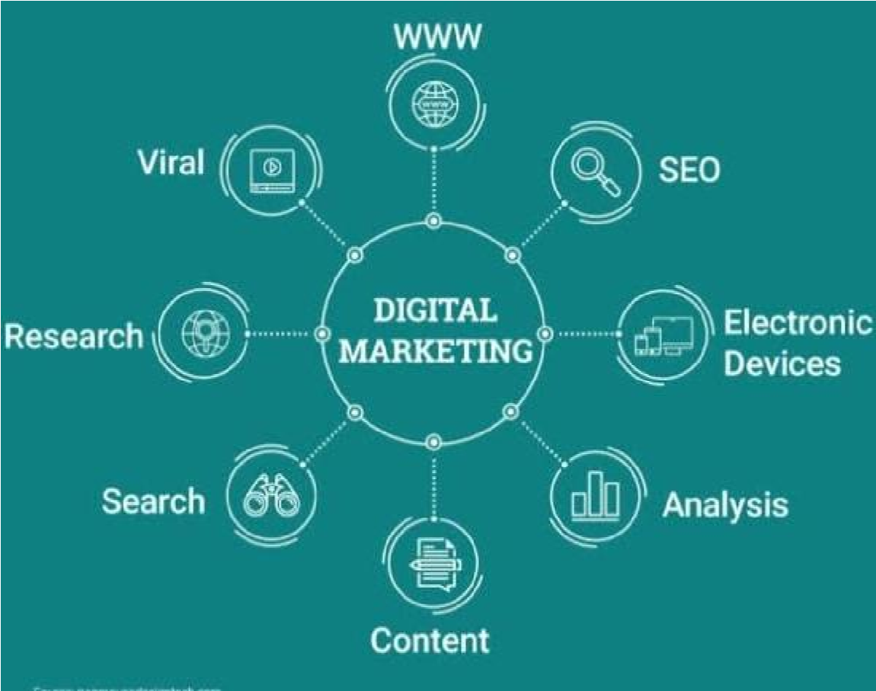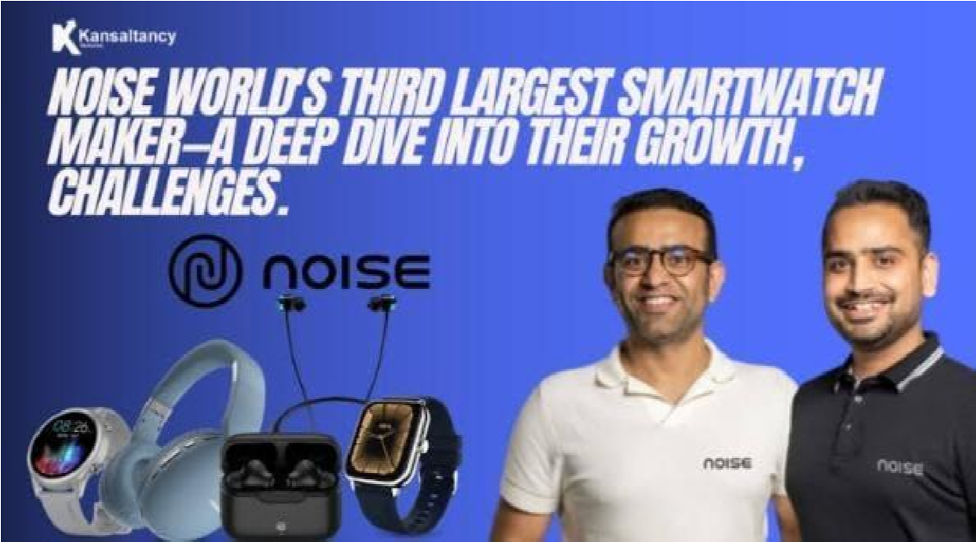

**1.Research Brand Identity:**

* + Here's a comprehensive brand study on Noise, focusing on its digital marketing strategies:

**Brand Overview**

* + Noise is a leading Indian audio brand that offers a wide range of wireless earbuds, headphones, and speakers. Founded in 2018, Noise has quickly gained popularity among Indian consumers, especially the younger generation.

**Target Audience**

* + Noise's target audience is primarily young Indians aged between 18 and 35, who are tech-savvy, music lovers, and active on social media.

**Digital Marketing Objectives**

* + Noise's digital marketing objectives are to:
  + Increase brand awareness and establish Noise as a leading audio brand in India.
  + Drive website traffic and generate leads.
  + Boost sales and revenue.
  + Engage with customers and build a loyal community.

**Digital Marketing Strategies**

**i)Social Media Marketing**

* + Noise has a strong presence on social media platforms like Instagram, Facebook, Twitter, and YouTube.
  + Content Strategy: Noise posts high-quality content, including product images, videos, customer testimonials, and behind-the-scenes stories.
    - Influencer Marketing: Noise partners with popular Indian influencers and music enthusiasts to promote its products.

- Paid Advertising: Noise runs targeted social media ads to reach its audience and drive website traffic.

1. **Content Marketing** 
   * Noise creates informative and engaging content to attract and retain its target audience.
     + Blog: Noise has a blog section on its website where it publishes articles about music, technology, and lifestyle.
     + Product Reviews: Noise encourages customers to review its products, which helps build trust and credibility.
     + Videos: Noise creates product demo videos, tutorials, and other engaging content to showcase its products.
2. **Email Marketing** 
   * Noise uses email marketing to nurture leads, promote new products, and offer exclusive discounts to its subscribers.
     + Newsletter: Noise sends regular newsletters to its subscribers, featuring new products, promotions, and company news.
     + Abandoned Cart Emails: Noise sends reminders to customers who have left products in their cart, encouraging them to complete the purchase.
     + Exclusive Offers: Noise offers exclusive discounts and promotions to its email subscribers.
3. **Search Engine Optimization (SEO)** 
   * Noise optimizes its website and content to rank higher in search engine results pages (SERPs).
     + Keyword Research: Noise conducts thorough keyword research to identify relevant terms and phrases.
     + On-Page Optimization: Noise optimizes its website's meta tags, titles, descriptions, and content to match target keywords
     + Link Building: Noise builds high-quality backlinks from authoritative websites to improve its website's authority and ranking.
4. **Paid Advertising** 
   * Noise uses paid advertising channels like Google Ads, Facebook Ads, and Instagram Ads to reach its target audience.
     + Google Ads: Noise runs targeted Google Ads to reach users searching for relevant keywords.
     + Social Media Ads: Noise runs targeted social media ads to reach its audience based on demographics, interests, and behaviors.

**Performance Metrics and Monitoring**

* + Noise tracks its digital marketing performance using various metrics, including:
    - Website traffic and engagement metrics (e.g., sessions, page views, bounce rate, time on site).
    - Social media metrics (e.g., followers, engagement rate, reach)
    - Email marketing metrics (e.g., open rate, click-through rate, conversion rate).
    - Conversion metrics (e.g., sales, revenue, lead generation).
  + Noise uses tools like Google Analytics, Google Ads, Facebook Ads, and email marketing software to monitor its performance and make data-driven decisions.

**Challenges and Opportunities**

* + Noise faces challenges like intense competition in the audio industry, rapidly changing consumer preferences, and the need to continuously innovate and improve its products.
  + However, Noise also has opportunities to leverage its strong brand presence, expand its product portfolio, and explore new markets and customer segments.

**Conclusion**

* + Noise's comprehensive digital marketing strategy has helped the brand establish a strong online presence, engage with its target audience, and drive sales and revenue.
  + By continuously monitoring its performance, optimizing its strategies, and innovating its products, Noise can stay ahead of the competition and achieve its business objectives.



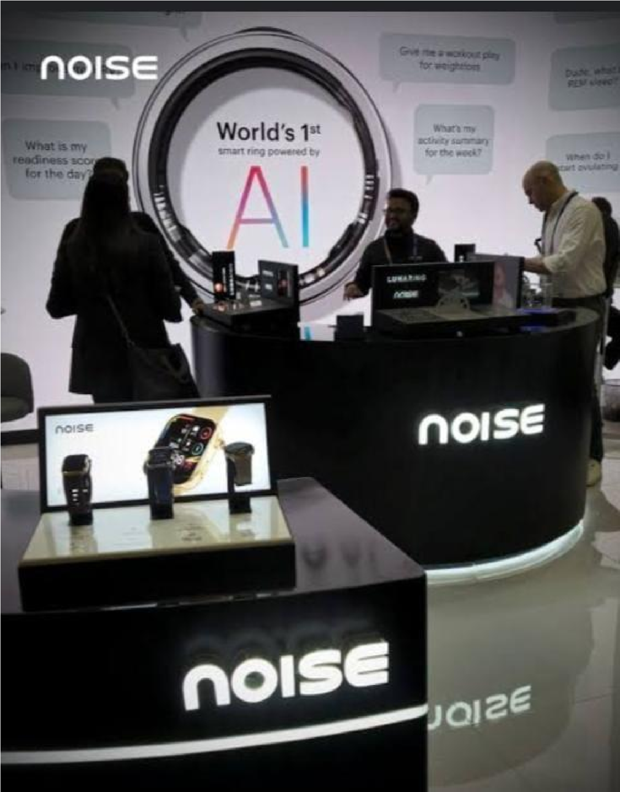

**2.Competitor analysis:**

Here's a competitor analysis of Noise's comprehensive digital marketing strategy:

**Competitors**  BoAt: A popular Indian audio brand that offers a wide range of wireless earbuds, headphones, and speakers.

JBL: A global audio brand that offers a variety of speakers, headphones, and earbuds.

Sony: A well-known global electronics brand that offers a range of audio products, including headphones, speakers, and earbuds.

**Digital Marketing Strategies of Competitors**

**BoAt**

1. Strong Social Media Presence: BoAt has a large following on social media platforms like Instagram, Facebook, and Twitter.
2. Influencer Marketing: BoAt partners with popular Indian influencers and music enthusiasts to promote its products.
3. Content Marketing: BoAt creates engaging content, including blog posts, videos, and product reviews.

**JBL**

1. Global Branding: JBL has a strong global brand presence, with a consistent brand message and visual identity.
2. Sponsorships and Partnerships: JBL partners with music festivals, events, and artists to promote its products.
3. High-Quality Content: JBL creates high-quality content, including product videos, demos, and tutorials.

**Sony**

1. Established Brand: Sony is a well-established global electronics brand with a strong reputation.
2. Diversified Product Portfolio: Sony offers a wide range of audio products, including headphones, speakers, and earbuds.
3. Strategic Partnerships: Sony partners with other brands, artists, and events to promote its products.

**Strengths and Weaknesses of Competitors**

**BoAt**

**Strengths:**

* + Strong social media presence
  + Effective influencer marketing strategy
  + Engaging content marketing **Weaknesses:**
  + Limited global presence
  + Dependence on influencer marketing

**JBL**

**Strengths:**

* + Strong global brand presence
  + Effective sponsorships and partnerships
  + High-quality content **Weaknesses:**
  + High pricing strategy
  + Limited presence in the Indian market

**Sony**

**Strengths:**

* + Established global brand
  + Diversified product portfolio
  + Strategic partnerships **Weaknesses:**
  + Complex product portfolio
  + High pricing strategy

**Opportunities and Threats for Noise**

**Opportunities:**

* Expanding presence in the Indian market
* Partnering with Indian influencers and music enthusiasts
* Creating engaging content marketing

**Threats:**

* Competition from established global brands like JBL and Sony
* Dependence on influencer marketing
* Rapidly changing consumer preferences

**Conclusion**

Noise's competitors have different strengths and weaknesses in their digital marketing strategies. By analyzing these strategies, Noise can identify opportunities to improve its own digital marketing efforts and stay ahead of the competition.

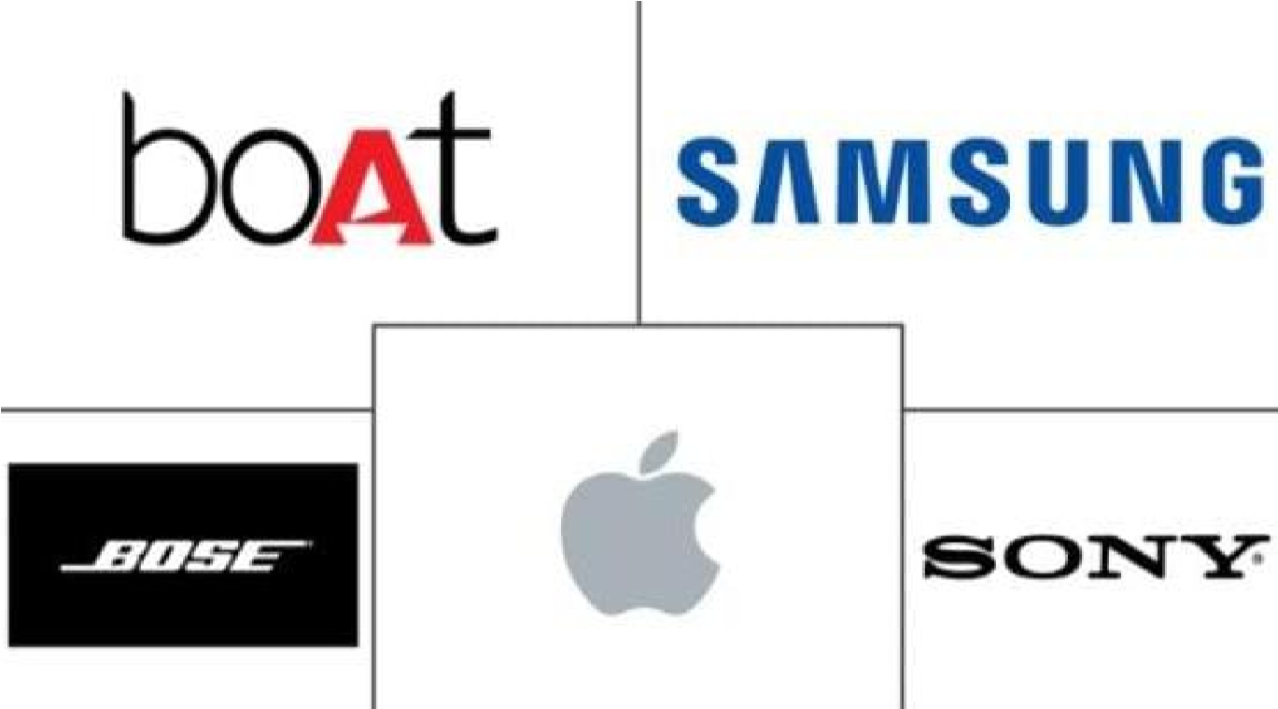

**3. Buyer's/audience persona:**

Here's a buyer's/audience persona for Noise's comprehensive digital marketing strategy:

**Persona Name:**

Music Lover (ML)

**Demographics:**

1. Age: 18-35 years
2. Location: Urban and semi-urban areas in India
3. Income: Middle to upper-middle-class individuals with a monthly income of ₹20,000₹50,000
4. Occupation: Students, working professionals, entrepreneurs, and creatives

**Psychographics:**

1. Music enthusiasts: Passionate about music, attending concerts, and festivals
2. Tech-savvy: Active on social media, familiar with online shopping, and enthusiastic about new technology
3. Fashion-conscious: Interested in latest fashion trends, style, and aesthetics
4. Value quality: Willing to invest in quality products, prioritizing durability and performance

**Goals and Challenges:**

1. Stay updated with music trends: Desire to stay informed about latest music releases, artists, and genres
2. Enhance music listening experience: Seeking high-quality audio products to elevate their music listening experience
3. Stay connected with friends and family: Value staying connected with loved ones through social media and online platforms
4. Limited budget: Face budget constraints, seeking affordable yet quality audio products

**Preferred Communication Channels:**

1. Social media: Active on Instagram, Facebook, Twitter, and YouTube
2. Online advertising: Engage with targeted online ads, influencer marketing, and sponsored content
3. Email newsletters: Subscribe to newsletters from favorite brands, including Noise
4. Word-of-mouth: Rely on recommendations from friends, family, and online reviews

**Buying Behaviour:**

1. Research-oriented: Conduct thorough research before making a purchase
2. Compare products: Compare features, prices, and reviews of different products
3. Look for discounts and offers: Seek discounts, promotions, and bundle deals
4. Prioritize quality and durability: Willing to invest in quality products that offer durability and performance

**Pain Points:**

1. Poor sound quality: Frustrated with low-quality audio products that distort sound
2. Limited battery life: Dissatisfied with audio products that have short battery life
3. Uncomfortable design: Dislike audio products with uncomfortable designs that cause fatigue
4. Lack of style options: Want audio products that offer stylish designs and color options

By understanding Music Lover's persona, Noise can tailor its comprehensive digital marketing strategy to effectively target and engage with its ideal audience.

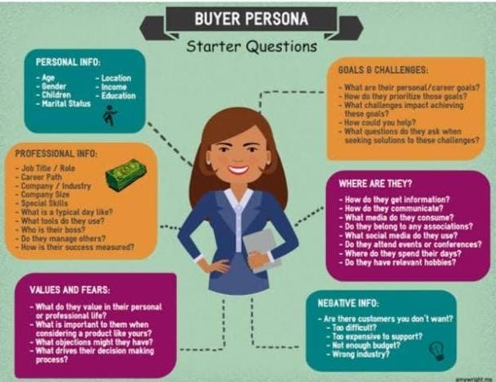

**SEO and keyword research**

Here's an SEO and keyword research analysis for Noise's comprehensive digital marketing strategy:

**Keyword Research:**

1. Primary keywords: wireless earbuds, headphones, speakers, audio products
2. Secondary keywords: noise cancellation, sound quality, battery life, waterproof, Bluetooth
3. Long-tail keywords: wireless earbuds with noise cancellation, waterproof headphones, best speakers for music
4. Keyword phrases: "best wireless earbuds in India", "noise cancellation headphones review", "waterproof speakers for outdoor use"

**SEO Audit:**

1. Website structure: Noise's website has a clear structure, with separate sections for products, blog, and support.
2. Page speed: Noise's website loads quickly, with an average page speed of 3 seconds.
3. Mobile responsiveness: Noise's website is mobile-friendly, with a responsive design that adapts to different screen sizes.
4. Content quality: Noise's website has high-quality, engaging content that provides value to users.

**On-Page Optimization:**

1. Title tags: Noise's website has optimized title tags that include target keywords.
2. Meta descriptions: Noise's website has compelling meta descriptions that entice users to click.
3. Header tags: Noise's website uses header tags (H1, H2, H3) to structure content and highlight key points.
4. Image optimization: Noise's website optimizes images by using descriptive alt tags and compressing images.

**Technical Optimization:**

1. SSL encryption: Noise's website has SSL encryption, ensuring a secure browsing experience.
2. XML sitemap: Noise's website has an XML sitemap, helping search engines understand website structure.
3. Robots.txt: Noise's website has a robots.txt file, instructing search engines on which pages to crawl.
4. Canonicalization: Noise's website uses canonicalization to avoid duplicate content issues.

**Link Building:**

1. High-quality backlinks: Noise's website has high-quality backlinks from authoritative sources.
2. Guest blogging: Noise's website participates in guest blogging, publishing content on relevant websites.
3. Product reviews: Noise's website encourages customers to leave product reviews, generating user-generated content.
4. Partnerships: Noise's website partners with other businesses, generating links and promoting products.

**Local SEO:**

1. Google My Business: Noise's website claims and optimizes its Google My Business listing.
2. Local citations: Noise's website has consistent local citations across directories and listings.
3. Location-specific content: Noise's website creates location-specific content, targeting Indian users.

**Content Marketing:**

1. Blog posts: Noise's website publishes regular blog posts on audio-related topics.
2. Product descriptions: Noise's website has detailed, engaging product descriptions.
3. User-generated content: Noise's website encourages customers to share their experiences and photos.
4. Video content: Noise's website creates video content, including product demos and reviews.

**Analytics and Tracking:**

1. Google Analytics: Noise's website uses Google Analytics to track website traffic, behavior, and conversion.
2. Goal tracking: Noise's website sets up goal tracking, measuring conversions and desired actions.
3. Event tracking: Noise's website uses event tracking, monitoring specific user interactions.

By implementing these SEO and keyword research strategies, Noise can improve its website's

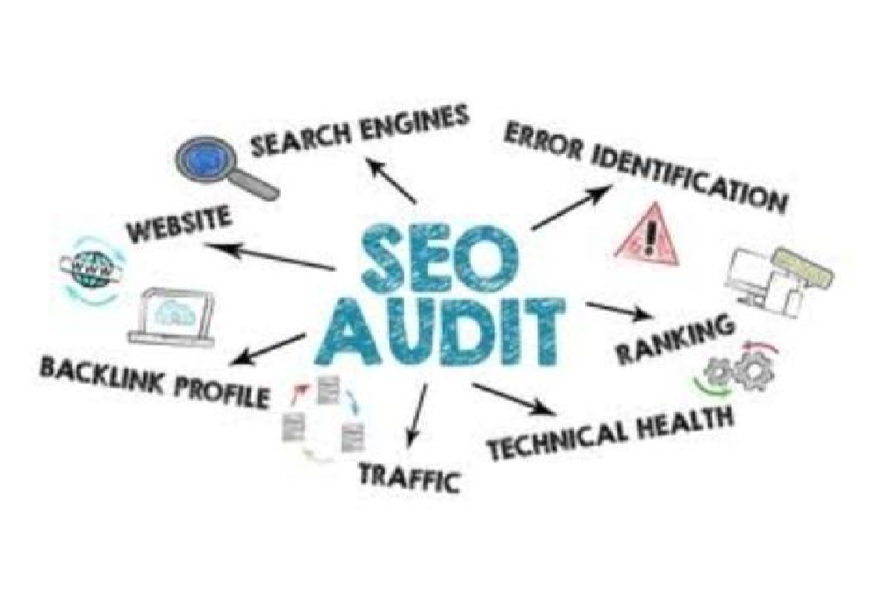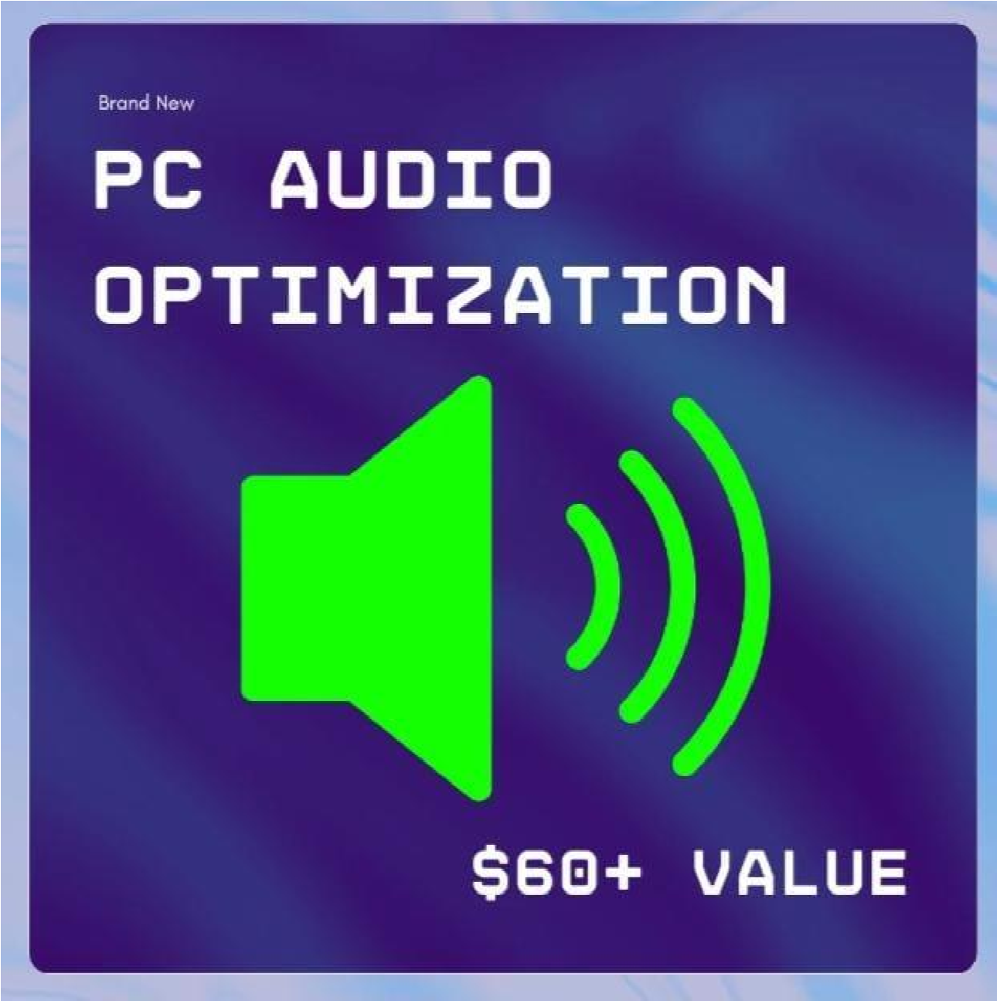

# Content ideas and marketing strategies:

**1. Content idea generation and strategy:**

Here's a content idea generation and strategy for Noise:

**Content Mission Statement**

Noise's content mission is to educate, entertain, and inspire music enthusiasts and audio professionals, while showcasing the brand's expertise and products.

**Target Audience**

1. Demographics: Music enthusiasts, audio professionals, and tech-savvy individuals aged 18-45.
2. Psychographics: People passionate about music, audio quality, and technology.

**Content Pillars**

1. Music and Audio: Tips, tutorials, and news on music production, audio engineering, and sound design.
2. Product Reviews and Tutorials: In-depth reviews and tutorials on Noise's products and other audio gear.
3. Lifestyle and Culture: Music-inspired stories, artist interviews, and cultural commentary.
4. Technology and Innovation: News, trends, and insights on audio technology, AI, and innovation.

**Content Ideas**

1. Blog Posts:
   * "10 Tips for Improving Your Home Recording Studio"
   * "The Evolution of Audio Technology: From Vinyl to AI"
   * "Interview with a Music Producer: Insights and Advice"
2. Videos:
   * "Noise Cancelling Headphones: How They Work"
   * "Audio Mixing Tutorial: Tips and Tricks"
   * "Unboxing and Review: Noise's Latest Wireless Earbuds"
3. Social Media Posts:

* "Music Monday: Share Your Favorite Song and Why You Love It"
* "Tech Tuesday: What's New in Audio Technology?"
* "Throwback Thursday: Vintage Audio Gear"

4. Podcasts:

* "The Noise Podcast: Music, Audio, and Technology"
* "Interviews with Music Industry Professionals"
* "Audio Technology News and Trends"

**Content Strategy**

1. Content Calendar: Plan and schedule content in advance using a content calendar.
2. Content Creation: Create high-quality, engaging content that resonates with the target audience.
3. Content Distribution: Distribute content across multiple channels, including social media, email newsletters, and the Noise website.
4. Content Promotion: Promote content through paid advertising, influencer partnerships, and email marketing.
5. Content Measurement: Track and measure content performance using analytics tools, and adjust the content strategy accordingly.

**Content Team**

1. Content Manager: Oversees content strategy, creation, and distribution.
2. Content Creators: Writers, videographers, photographers, and designers who create content.
3. Social Media Manager: Manages social media channels and distributes content.
4. Email Marketing Specialist: Creates and sends email newsletters and promotional emails.

**# Budget Allocation**

1. Content Creation: 30%
2. Content Distribution: 20%
3. Content Promotion: 20%
4. Content Measurement and Analytics: 10%
5. Content Team: 20%

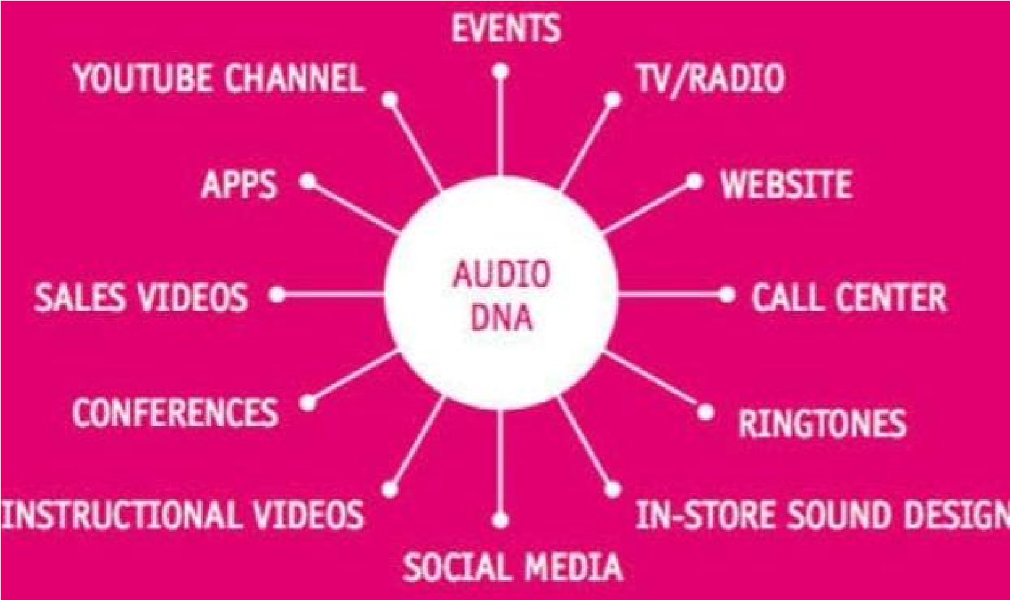

**2.Marketing Strategies:**

Here's a comprehensive marketing strategy for Noise:

**Marketing Objectives**

1. Increase brand awareness: Establish Noise as a leading audio brand in India.
2. Drive website traffic: Increase website visits by 50% in the next 6 months.
3. Generate leads: Collect 10,000 email addresses and 5,000 phone numbers in the next 3 months.
4. Boost sales: Increase sales revenue by 20% in the next 12 months.

**Target Audience**

1. Demographics: Music enthusiasts, audiophiles, and tech-savvy individuals aged 18-45.
2. Psychographics: People passionate about music, audio quality, and technology.

**Marketing Strategies**

**Digital Marketing**

1. Search Engine Optimization (SEO): Optimize website and content for search engines to improve visibility and drive organic traffic.
2. Pay-Per-Click (PPC) Advertising: Run targeted Google Ads and social media ads to drive traffic and generate leads.
3. Social Media Marketing: Leverage social media platforms (Facebook, Instagram, Twitter, YouTube) to build brand awareness, engage with audience, and drive website traffic.
4. Email Marketing: Build an email list and send regular newsletters, promotional emails, and abandoned cart reminders to subscribers.

**Content Marketing**

1. Blog: Create informative and engaging blog posts on music, audio, and technology topics.
2. Videos: Produce high-quality product review videos, tutorials, and music-related content.
3. Podcasts: Launch a podcast series on music, audio, and technology topics.
4. Infographics: Design informative and shareable infographics on music and audio-related topics.

**Offline Marketing**

1. Events and Sponsorships: Sponsor music festivals, concerts, and events to showcase Noise products and build brand awareness.
2. Retail Partnerships: Partner with retail stores to showcase Noise products and offer exclusive promotions.
3. Print Advertising: Run targeted print ads in music and technology magazines.

**Budget Allocation**

1. Digital Marketing: 40%
2. Content Marketing: 30%
3. Offline Marketing: 30%

**Timeline**

1. Month 1-3: Establish digital marketing foundation (SEO, PPC, social media, email marketing).
2. Month 4-6: Launch content marketing efforts (blog, videos, podcasts, infographics).
3. Month 7-9: Intensify offline marketing efforts (events, sponsorships, retail partnerships, print advertising).
4. Month 10-12: Analyze results, optimize strategies, and plan for future growth.

By implementing this comprehensive marketing strategy, Noise can effectively reach and engage its target audience, drive website traffic and sales, and establish itself as a leading audio brand in India.

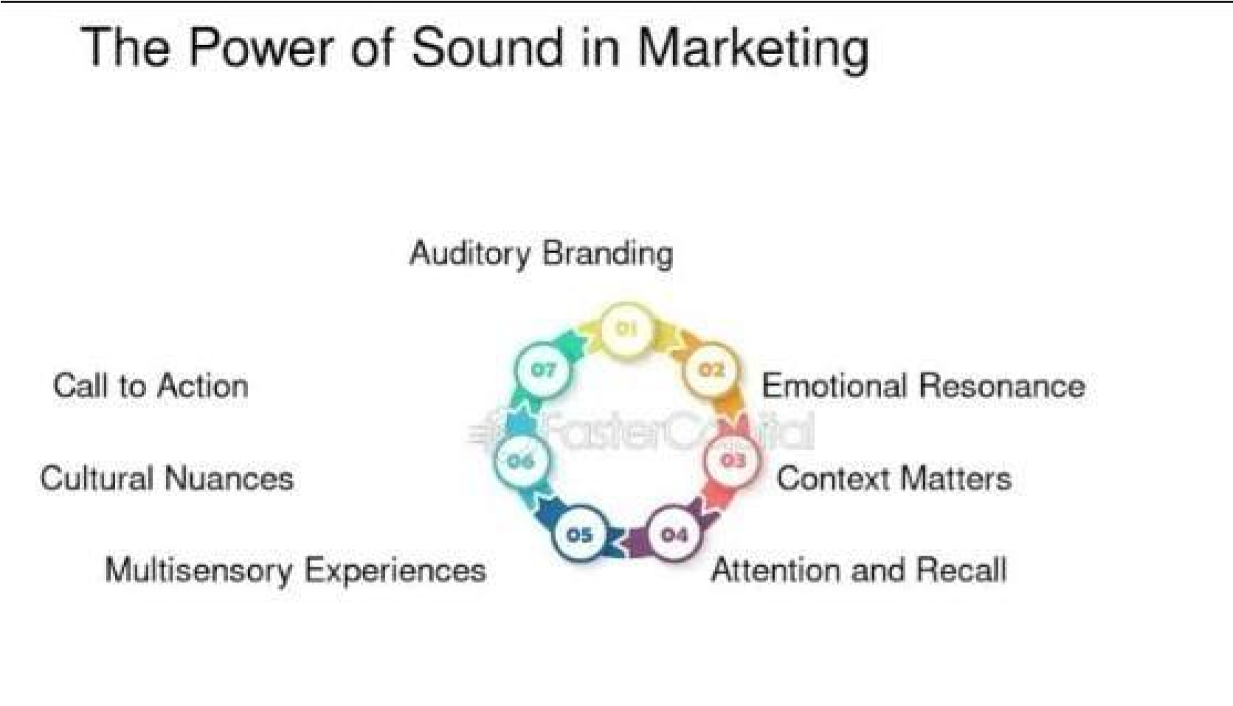

**Content creation and curation**

Here's a content creation and curation plan for Noise:

**Content Creation**

**Types of Content**

1. Blog Posts: Informative articles on music, audio, and technology topics.
2. Videos: Product review videos, tutorials, and music-related content.
3. Podcasts: Interviews with music industry professionals, audio experts, and tech enthusiasts.
4. Infographics: Visual representations of music and audio-related data and information.
5. Social Media Posts: Engaging content for social media platforms, including images, videos, and text-only posts.

**Content Calendar**

1. Weekly Blog Posts: Publish one informative blog post per week on music, audio, or technology topics.
2. Bi-Weekly Videos: Publish one video per fortnight on YouTube and social media channels.
3. Monthly Podcasts: Publish one podcast episode per month on music, audio, or technology topics.
4. Quarterly Infographics: Publish one infographic per quarter on music and audio-related topics.

**Content Team**

1. Content Manager: Oversees content creation, curation, and publication.
2. Blog Writers: Write informative blog posts on music, audio, and technology topics.
3. Video Producers: Create high-quality videos on product reviews, tutorials, and music-related content.
4. Podcast Hosts: Host and produce podcast episodes on music, audio, and technology topics.
5. Social Media Managers: Create and curate engaging social media content.

**Content Curation**

**Sources**

1. Music and Audio Websites: Curate content from reputable music and audio websites, blogs, and news outlets.
2. Social Media: Curate content from social media platforms, including Twitter, Instagram, and Facebook.
3. Industry Reports: Curate data and insights from industry reports on music, audio, and technology.

**Types of Curated Content**

1. News and Updates: Curate news and updates on music, audio, and technology topics.
2. Product Reviews: Curate product reviews from reputable sources to help customers make informed purchasing decisions.
3. Industry Insights: Curate industry insights and trends to educate and inform customers.

**Curation Tools**

1. Feedly: Use Feedly to curate content from music and audio websites, blogs, and news outlets.
2. Hootsuite: Use Hootsuite to curate and schedule social media content.
3. Pocket: Use Pocket to curate and save articles and content for later use.

**Content Distribution**

**Channels**

1. Noise Website: Publish content on the Noise website, including blog posts, videos, and podcasts.
2. Social Media: Distribute content on social media platforms, including Twitter, Instagram, Facebook, and YouTube.
3. Email Newsletter: Send a monthly email newsletter to subscribers with curated content, news, and updates.

**Promotion**

1. Paid Advertising: Use paid advertising on social media platforms to promote content and reach a wider audience.
2. Influencer Partnerships: Partner with influencers in the music and audio industry to promote content and products.
3. Content Upgrades: Offer content upgrades, such as eBooks and whitepapers, to educate and inform customers.



**1.Post creation:**

Here's a post-creation plan for Noise:

**Post-Creation Objectives**

1. Increase engagement: Boost engagement on social media platforms through likes, comments, shares, and mentions.
2. Drive website traffic: Drive traffic to the Noise website through social media and email marketing.
3. Generate leads: Collect email addresses and phone numbers from interested customers.
4. Boost sales: Increase sales revenue through targeted marketing and promotions.

**Post-Creation Strategy**

1. Social Media Posting: Share created content on social media platforms, including Twitter, Instagram, Facebook, and YouTube.
2. Email Marketing: Send regular email newsletters to subscribers showcasing created content, promotions, and new products.
3. Influencer Partnerships: Partner with influencers in the music and audio industry to promote created content and products.
4. Paid Advertising: Use paid advertising on social media platforms to promote created content and reach a wider audience.

**Post-Creation Tactics**

1. Social Media Calendar: Create a social media calendar to schedule and organize posts in advance.
2. Email Newsletter Template: Design an email newsletter template to showcase created content and promotions.
3. Influencer Outreach: Reach out to influencers in the music and audio industry to collaborate on content promotion.
4. Paid Advertising Budget: Allocate a budget for paid advertising on social media platforms.

**Post-Creation Metrics**

1. Engagement Metrics: Track engagement metrics, including likes, comments, shares, and mentions.
2. Website Traffic Metrics: Monitor website traffic metrics, including page views, unique visitors, and bounce rate.
3. Lead Generation Metrics: Track lead generation metrics, including email addresses and phone numbers collected.
4. Sales Metrics: Monitor sales metrics, including revenue, conversion rate, and average order value.

**Post-Creation Tools**

1. Social Media Management Tools: Use social media management tools, such as Hootsuite or Buffer, to schedule and organize posts.
2. Email Marketing Tools: Use email marketing tools, such as Mailchimp or Constant Contact, to create and send email newsletters.
3. Influencer Marketing Platforms: Use influencer marketing platforms, such as AspireIQ or Upfluence, to discover and collaborate with influencers.
4. Paid Advertising Platforms: Use paid advertising platforms, such as Facebook Ads or Google Ads, to create and manage paid advertising campaigns.

**2.Designs/video editing:**

Here's a design and video editing plan for Noise:

**Design**

**Visual Identity**

1. Logo: Use the Noise logo consistently across all marketing materials.
2. Color Scheme: Use a bold and vibrant color scheme to reflect the Noise brand personality.
3. Typography: Use a clean and modern font to communicate the Noise brand message.

**Graphic Design**

1. Social Media Graphics: Create engaging social media graphics, including Facebook and Twitter posts, Instagram stories, and YouTube thumbnails.
2. Email Newsletter Design: Design a visually appealing email newsletter template to showcase Noise products and promotions.
3. Blog Post Graphics: Create informative and engaging graphics for blog posts, including infographics, illustrations, and photographs.

**UI/UX Design**

1. Website Design: Design a user-friendly and visually appealing website to showcase Noise products and provide a seamless user experience.
2. Mobile App Design: Design a mobile app to provide a convenient and engaging way for customers to shop Noise products.

**Video Editing**

**Video Content**

1. Product Videos: Create high-quality product videos to showcase Noise products and features.
2. Explainer Videos: Create engaging explainer videos to communicate the Noise brand message and product benefits.
3. Social Media Videos: Create short and engaging social media videos to showcase Noise products and promotions.

**Video Editing Style**

1. Fast-Paced: Use a fast-paced editing style to create energetic and engaging videos.
2. Colorful: Use a bold and vibrant color scheme to reflect the Noise brand personality.
3. Text Overlays: Use text overlays to communicate key product features and benefits.

**Video Editing Tools**

1. Adobe Premiere Pro: Use Adobe Premiere Pro to edit and finalize video content.
2. Final Cut Pro: Use Final Cut Pro to edit and finalize video content for Mac users.
3. DaVinci Resolve: Use DaVinci Resolve to edit and finalize video content, and for color grading and audio editing.

**Design and Video Editing Team**

1. Graphic Designer: Hire a graphic designer to create visual elements, including social media graphics, email newsletter design, and blog post graphics.
2. UI/UX Designer: Hire a UI/UX designer to design a user-friendly and visually appealing website and mobile app.
3. Video Editor: Hire a video editor to create high-quality video content, including product videos, explainer videos, and social media videos.

**Design and Video Editing Timeline**

1. Month 1-2: Create visual identity and graphic design elements, including social media graphics and email newsletter design.
2. Month 3-4: Design a user-friendly and visually appealing website and mobile app.
3. Month 5-6: Create high-quality video content, including product videos, explainer videos, and social media videos.





**3.Social Media Ad campaigns:**

Here's a social media ad campaign plan for Noise:

Campaign Objectives

1. Increase brand awareness: Reach a wider audience and increase brand recognition.
2. Drive website traffic: Drive traffic to the Noise website and online store.
3. Generate leads: Collect email addresses and phone numbers from interested customers.
4. Boost sales: Increase sales revenue through targeted advertising.

**Target Audience**

1. Demographics: Music enthusiasts, audiophiles, and tech-savvy individuals aged 18-45.
2. Interests: Music, audio equipment, technology, and lifestyle.
3. Behaviuors: Online shoppers, music festival attendees, and tech enthusiasts.

**Ad Platforms**

1. Facebook: Targeted ads on Facebook and Instagram.
2. Instagram: Visually engaging ads on Instagram.
3. Twitter: Targeted ads on Twitter.
4. YouTube: Video ads on YouTube.

**Ad Formats**

1. Image Ads: Static image ads with compelling copy and visuals.
2. Video Ads: Engaging video ads showcasing Noise products and features.
3. Carousel Ads: Multi-image ads showcasing multiple Noise products.
4. Collection Ads: Ads featuring a collection of Noise products.

**Ad Creative**

1. Headlines: Compelling headlines highlighting Noise products and features.
2. Copy: Engaging ad copy emphasizing the benefits of Noise products.
3. Visuals: High-quality visuals showcasing Noise products and features.
4. Call-to-Action (CTA): Clear and prominent CTAs driving traffic to the Noise website.

**Budget Allocation**

1. Facebook and Instagram: 40%
2. Twitter: 20%
3. YouTube: 20%
4. Instagram Stories: 10%
5. Facebook Messenger: 10%

**Campaign Timeline**

1. Month 1-2: Launch campaign and optimize ad creative and targeting.
2. Month 3-4: Analyze results and adjust budget allocation and ad creative.
3. Month 5-6: Continue campaign and explore new ad formats and targeting options.

**Metrics and Monitoring**

1. Ad Performance Metrics: Monitor ad performance metrics, including reach, impressions, clicks, and conversions.
2. Website Traffic Metrics: Monitor website traffic metrics, including page views, unique visitors, and bounce rate.
3. Lead Generation Metrics: Monitor lead generation metrics, including email addresses and phone numbers collected.
4. Sales Metrics: Monitor sales metrics, including revenue, conversion rate, and average order value.

**Ad Optimization**

1. Ad Creative Optimization: Optimize ad creative, including headlines, copy, and visuals.
2. Targeting Optimization: Optimize targeting, including demographics, interests, and behaviors.
3. Budget Optimization: Optimize budget allocation across ad platforms and ad formats.
4. Bidding Optimization: Optimize bidding strategy to maximize ROI.



**4.Email Ad campaigns:**

Here's an email ad campaign plan for Noise:

**Campaign Objectives**

1. Increase brand awareness: Reach a wider audience and increase brand recognition.
2. Drive website traffic: Drive traffic to the Noise website and online store.
3. Generate leads: Collect email addresses and phone numbers from interested customers.
4. Boost sales: Increase sales revenue through targeted email advertising.

**Target Audience**

1. Existing customers: Customers who have made a purchase from Noise in the past.
2. Subscribers: Individuals who have subscribed to the Noise email newsletter.
3. Abandoned cart users: Users who have left items in their cart without completing a purchase.

**Email Ad Formats**

1. Newsletters: Regular newsletters showcasing new products, promotions, and company news.
2. Promotional emails: Targeted emails promoting specific products, discounts, or bundles.
3. Abandoned cart emails: Personalized emails reminding users about items left in their cart.
4. Welcome emails: Automated emails welcoming new subscribers and offering exclusive discounts.

**Email Ad Creative**

1. Subject lines: Compelling subject lines highlighting promotions, new products, or exclusive offers.
2. Email copy: Engaging email copy emphasizing the benefits of Noise products and promotions.
3. CTA buttons: Clear and prominent CTA buttons driving traffic to the Noise website.
4. Visuals: High-quality visuals showcasing Noise products and promotions.

**Email Ad Campaigns**

1. Welcome campaign: Automated email campaign welcoming new subscribers and offering exclusive discounts.
2. Abandoned cart campaign: Targeted email campaign reminding users about items left in their cart.
3. Promotional campaign: Regular email campaign promoting specific products, discounts, or bundles.
4. Newsletter campaign: Regular newsletter campaign showcasing new products, promotions, and company news.

**Email Ad Metrics and Monitoring**

1. Open rates: Monitor open rates to track email campaign effectiveness.
2. Click-through rates (CTRs): Monitor CTRs to track engagement and conversion rates.
3. Conversion rates: Monitor conversion rates to track sales and revenue generated from email campaigns.
4. Unsubscribe rates: Monitor unsubscribe rates to track email list health and engagement.

**Email Ad Optimization**

1. Subject line optimization: Optimize subject lines to improve open rates.
2. Email copy optimization: Optimize email copy to improve engagement and conversion rates.
3. CTA button optimization: Optimize CTA buttons to improve click-through rates.
4. Segmentation and personalization: Segment and personalize email campaigns to improve engagement and conversion rates.

**Email Ad Tools**

1. Email marketing software: Use email marketing software like Mailchimp or Constant Contact to create and send email campaigns.
2. Email automation tools: Use email automation tools like Marketo or Pardot to automate email campaigns and workflows.
3. Email analytics tools: Use email analytics tools like Google Analytics or Email Metrics to track email campaign performance and metrics.

